# Virtual Visits, Telephonic Visits & Telehealth PRR & Call Center Cheat Sheet

## SCHEDULING REMINDERS

1. All Pts being scheduled per Grid for Essential Services/Telephonic telephonic), Center Agents to complete a mini registration over the phone to include:
   1. Verify and Update Address
   2. Verify and Update Phone Number
   3. Verify and Update Insurance is still the same *(advise Pt Ins care readily available on the day of apt)*

|  |  |
| --- | --- |
| **Category** | **Medical** |
| **Essential Services**  **on Site via POD/Virtual Care** | IF PTS SCREEN **NEGATIVE** (1.No Fever, 2.No Respiratory Complaints, 3. No Known Contact) OK TO SCHEDULE THESE VISITS:   * < than 16 months WCC ONLY * Essential injections *(B12, Testosterone)* * POCT Testing * Lab Work |
| **Telehealth Services**  ***(Use Script)*** | * Acute Visits, **including** patients with respiratory symptoms, * All other visits *(EXCLUDING NON ESSENTIAL BELOW)* schedule a telehealth visit with the Pts PCP on their Telephonic schedule |
| **New Patients** | * Schedule Essential Visits same as above for established patients |
| **PHONE NOTE TO PCP & RN for further triage** | * Follow normal procedures with no appointment availability or Urgent Triage |
| **NON ESSENTIAL**  **DO NOT SCHEDULE**  ***(Use Script)*** | * AWV * Physicals * WCC >16 months |

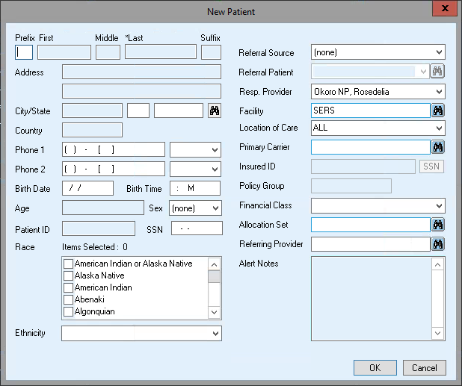

## Check In Tips & Tricks for Virtual Visits

1. Obtain paperwork as you would a normal visit.

## Check In Tips & Tricks for Telephone Health & Telehealth Visits

1. **What do I do if the Consent to Treat/Bill/HIPPA Boxes during registration are expired?**

The provider will be required to document in the chart verbal consent to treat and bill. Change this date to today’s date +1.

1. **What to do with Sliding Fee Scale?**
   1. Patients who come in for virtual/telehealth/telephone visits will be processed through the “Follow Up (Nurse Slide)”
   2. If a patient has an expired slide, they can be extended to 6/30/20 without reapplying. Print out and fill out a slide application noting that the slide is being extending related to COVID19 until 6/30/20 and sign and scan into chart.
   3. New Patients can self-attest verbally. A self-attest form should be filled out and scanned into the chart and noted that it was done verbally. Be sure to use the current process for of self-attestation. We are developing a second/third/fourth visit process.
2. How do I Collecting Payment?
   1. Please, please move patient to pay by credit card. Ask if they can use a friends/family members/get a gift card. We currently will accept credit card payment over the phone. We are developing an invoice processing process and move away from credit cards over the phone.
   2. If the patient wants cash????? Still working on it.

## What should I say (Scripts):

* 1. **Changing appointments to Telehealth**: I am calling on behalf of your provider XX.   we are calling to reschedule your apt on xx as a telephone visit *(get the best contact number and update the system).*   (insert instructions on telehealth) Your health is important to us and we want to limit your exposure.  Please be on the lookout for a call from your provider or a member of the care team on xx/xx at x:xxam *(schedule the next available apt with Pts PCP on their telephonic schedule).*  We are excited to be able to offer this new service.
  2. **Pt Calling Back due to Text/VM left to schedule Telehealth Visits**-In response to the coronavirus situation we are not scheduling or rescheduling certain routine visits at this time.  We would like to offer you an apt on xx as a telephone visit *(get the best contact number and update the system).*   (insert instructions on telehealth??) Your health is important to us and we want to limit your exposure.  Please be on the lookout for a call from your provider or a member of the care team on xx/xx at x:xxam *(schedule the next available apt with Pts PCP on their telephonic schedule).*  We are excited to be able to offer this new service.
  3. **NEW OR EST Patients calling to schedule NON-essential services:** : In response to the coronavirus epidemic, we are limiting our in-person visits. Your health is important to us and we want to limit your exposure. However, we have the option of scheduling a telephone visit with a provider. We would like to offer you an apt on xx as a telephone visit *(get the best contact number and update the system).*   (insert instructions on telehealth) Please be on the lookout for a call from your provider or a member of the care team on xx/xx at x:xxam *(schedule the next available apt with Pts PCP on their telephonic schedule).*  We are excited to be able to offer this new service
  4. **NEW OR EST Patients calling to schedule NON-essential services:** : In response to the coronavirus epidemic, we are limiting our in-person visits. Your health is important to us and we want to limit your exposure. However, we have the option of scheduling a telephone visit with a provider. We would like to offer you an apt on xx as a telephone visit *(get the best contact number and update the system).*   (insert instructions on telehealth) Please be on the lookout for a call from your provider or a member of the care team on xx/xx at x:xxam *(schedule the next available apt with Pts PCP on their telephonic schedule).*  We are excited to be able to offer this new service