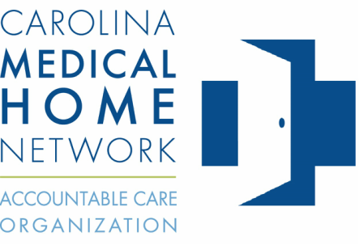

CHF POPULATION CLINICAL PATHWAY
Pathway  Component | Staff/Provider  Responsible
- Use eClinical Works data to identify ACO patients with CHF by PCP
- Institute standing orders for assessment & care management of CHF patients to include, at a minimum, vaccines & labs
- Schedule appointment for patient if no office visit within the last 3 months
- Conduct/update comprehensive health assessment to include:
Patient/family medical history
Patient/family mental health/substance use history; depression screening
Family/social/cultural characteristics
Lifestyle behaviors affecting health
SDOH – social determinants of health
Communication/health literacy needs
Advance care planning
- Establish list of current healthcare providers & suppliers
- Update problem list
- Conduct medication reconciliation:
ACE/ARB
Beta Blocker
- Assessment to stage CHF to include:
Symptoms
Clinical presentation
Activity
EF Echocardiogram
- Assessment for co-morbidities (anemia, COPD, sleep apnea)
- Medications titrated based on symptoms & clinical indicators
- Schedule AWV for eligible patients at conclusion of E&M office visit
- Enroll patient in Chronic Care Management
- Educate patient on disease self-management
- Educate patient on how to access the medical home—phone, after-hours, portal
Use I50 codes (ischemic cardiomyopathy & cardiomegaly do not map to HF HCC). Code for diagnosis if there are structural changes even if patient is asymptomatic. SEE Page 2 for CHF HCC CODES
ADDITIONAL CONSIDERATIONS
** Consult Cardiology when unable to stabilize patient
** Consider remote patient monitoring, home health, hospice or PACE (team)
** For patients not previously diagnosed but who have history of CAD,
HTN, DMII, consider the diagnosis & order Echocardiogram

Diagnosis  Code | Description | HCC
I501 | Left ventricular failure | Yes
I5020 | Unspecified systolic (congestive) heart failure | Yes
I5021 | Acute systolic (congestive) heart failure | Yes
I5022 | Chronic systolic (congestive) heart failure | Yes
I5023 | Acute on chronic systolic (congestive) heart failure | Yes
I5030 | Unspecified diastolic (congestive) heart failure | Yes
I5031 | Acute diastolic (congestive) heart failure | Yes
I5032 | Chronic diastolic (congestive) heart failure | Yes
I5033 | Acute on chronic diastolic (congestive) heart failure | Yes
I5040 | Unspecified combined systolic (congestive) and diastolic (congestive) heart failure | Yes
I5041 | Acute combined systolic (congestive) and diastolic (congestive) heart failure | Yes
I5042 | Chronic combined systolic (congestive) and diastolic (congestive) heart failure | Yes
I5043 | Acute on chronic combined systolic (congestive) and diastolic (congestive) heart failure | Yes
I509 | Heart failure, unspecified | Yes
I514 | Myocarditis, unspecified | Yes
I515 | Myocardial degeneration | Yes

