- Log in to eCW dashboards located at: https://caweb.eclinicalweb.com/portal/auth
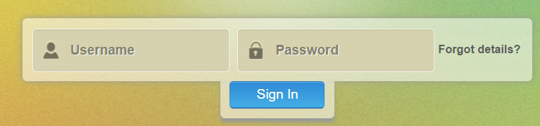

- Click on the NYU ED DASHBOARD. The focus is patients that have been to the ED in the last year with a primary diagnosis of COPD or CHF and the visit was either:
- Emergent Avoidable ED Admits: Emergency department care was required based on the complaint or procedures performed, resources used, but the emergent nature of the condition was potentially preventable/avoidable if timely and effective ambulatory care had been received during the episode of illness (e.g.: the flare-ups of asthma, diabetes, congestive heart failure, etc.)
- Emergent/Primary Care Treatable - Based on information in the record, treatment was required within 12 hours, but care could have been provided effectively and safely in a primary care setting. The complaint did not require continuous observation, and no procedures were performed or resources used that are not available in a primary care setting (e.g., CAT scan or certain lab tests);
- Non-Emergent ED Visits: The patient's initial complaint, presenting symptoms, vital signs, medical history and age indicated that immediate medical care was not required within 12 hours

- After the dashboard has completely loaded it will say ‘Ready’ in the lower left corner. If you are not seeing any data on your screen, but it says ‘Ready’ in the lower left corner, then you will need to clear your browser history; exit your browser and start again.

- On the Overview tab set the following filters:
  - Scorecard Filter – set ‘Claim Date Range’ to a current 12-month period. The end date of the range usually runs 60 days behind the current date. You can either click on the calendar and select the date or type the date into the date field.
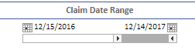
  - Demographics Filter – Attributed Now = Yes so you will need to uncheck ‘No’.
  - Bar Graph on the left acts as a filter and we want only the Emergent Avoidable + Non-Emergent + Primary Care Treatable bars to be light green (this means they are selected). Clicking on the bars will select or unselect that category. Press and hold your ‘Ctrl’ key and select more than one bar.

- Click on the Patient Level tab:
  - The filters that you set in step #2 above will carry-over to this tab
  - Claims Filter – scroll down to ‘Primary Diagnosis’ and for COPD patients, type “J44 OR J45” in the box that says, ‘Type to search in list’ and press enter. This will bring up all primary diagnosis codes that start with J44 or J45.
  - Press and hold the ‘Ctrl’ key and then select ALL the J44 and J45 codes that have populated the list. If you have done this correctly, the codes will be highlighted in blue.
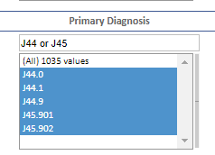

- A COPD patient list now appears on your screen. Hover over any patient name and RIGHT click and a small box will appear – select ‘Export table’
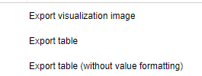

- The patient list file will appear in the lower left-hand side of your screen as a CSV file; open the file and do a ‘File, Save As’ and save this as an Excel file to the location of your choice. Since this list has PHI, be sure this is saved on a secure drive.
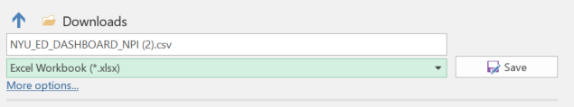
- To Filter and Sort the date:
  - Click on the ‘1’ on the far-left top row to highlight the row with the column header names
  - Under the ‘Home’ tab in excel, select ‘Sort & Filter; and click ‘Filter’
  - Each column header name will now have a down arrow; clicking on the down arrow will allow user to sort by this variable or limit the list to only the selected item (example: sort the # of ED Encounters from largest to smallest; limit list to only patients with more than xx visits)

- To see the entire column header name:
  - Click on the ‘1’ on the far left to highlight the row with the column header names
  - With the top row highlight, right click and select ‘Format Cells’
  - Click on ‘Alignment’ and ‘Wrap Text’.
  - Resize a column by hovering over the line between the column until you see a crosshair, the left click and drag the column to the desired width.

- After sorting, filtering and making any other changes do a ‘File, Save’ and then a ‘File, Print’ if you want to share the list with another user.

- Repeat this process for CHF patients, in step #3b above type in “I50 OR I11 OR I13”.

- The data is updated monthly by the end of the month, so run this list monthly to capture any new ED visits that fit these criteria.

