- Log in to eCW dashboards located at: https://caweb.eclinicalweb.com/portal/auth
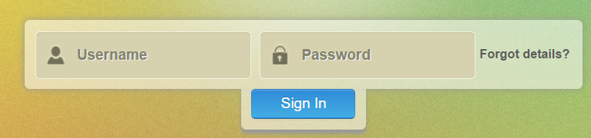
- Once you have logged in, click on the ‘Patient List’ dashboard.

- A patient list will populate that is a listing of all Medicare patients currently assigned to your health center through the Medicare Shared Saving Program. This list of patients will change quarterly, but the data within the list updates each month by the end of the month.

- Click on the ‘Cover Page’ tab, then Key Performance Indicators to access the definitions for the information contained on the Patient List. These definitions are also listed on page 3 of this document.
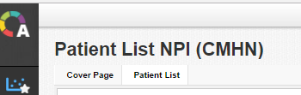
- Click on the “Patient List’ tab to generate a current patient list. This may take a few minutes to load. If you are not seeing any data on your screen, but it says ‘Ready’ in the lower left corner, then you will need to clear your browser history; exit your browser and start again.

- To download the patient list to excel, RIGHT click anywhere over the patient list and select ‘Export Table’
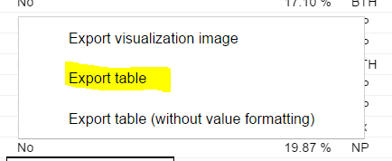

- The patient list file will appear in the lower left-hand side of your screen as a CSV file; open the file and do a ‘File, Save As’ and save this as an Excel file
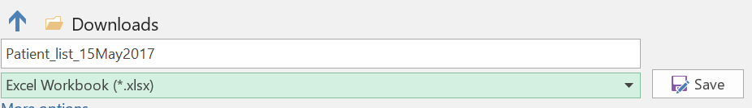

- To Filter and Sort the date:
  - Click on the ‘1’ on the far left top row to highlight the row with the column header names
  - Under the ‘Home’ tab in excel, select ‘Sort & Filter; and click ‘Filter’
  - Each column header name will now have a down arrow; clicking on the down arrow will allow user to sort by this variable or limit the list to only the selected item (example: sort the # of ED Encounters from largest to smallest; limit list to only patients with more than xx visits)

- To see the entire column header name:
  - Click on the ‘1’ on the far left to highlight the row with the column header names
  - With the top row highlight, right click and select ‘Format Cells’
  - Click on ‘Alignment’ and ‘Wrap Text’.
  - Resize a column by hovering over the line between the column until you see a crosshair, the left click and drag the column to the desired width.

- To target either CHF or COPD patients for care management intervention
  - Filter ‘CHF’ column to EXCLUDE NP (not present)
  - Filter ‘6 M IP Probability’ column to > 50% (can set this lower to yield more patients)
  - Filter ‘IP Hospital Admits’ >1
  - Filter ‘# of ED Encounters’ to > 3
  - Filter ‘Medicare Status’ to EXCLUDE ESRD patients

- After saving this list repeat this process using ‘COPD” in step #10a.

- After sorting, filtering and making any other changes do a ‘File, Save’ and then a ‘File, Print’ if you want to share the list with another user. Remember that you are using PHI, so patient lists must be kept secure following your health center’s protocol.

Patient List Definitions (located on the Cover Page tab)
- Patient list defaults to currently alive and assigned patients in most recent quarter and present in monthly CMS claims data
- Unless otherwise specified this reports covers a 12-month time period plus a 3 month claims run out
- HIC # is the Medicare identification number
- Medicare Status: Aged with ESRD (End Stage Renal Disease); Aged without ESRD; Disabled with ESRD; Disabled without ESRD; ESRD only
- PCP Name: Attributed PCP based on eCW attribution logic
- Most Recent Encounter Date - can be any provider inside or outside of your health center, including mid-levels
- Most Recent Encounter PCP (Primary Care Provider) - can be any provider inside or outside of your health center, including mid-levels
- Most Recent Encounter PCP Specialty
- Most Recent ACO Encounter Date: Date of the most recent Medicare claim (Part A or B) related to an ACO Physician (MD/DO) encounter (MD/DO must be listed on the CMS provider list).
- Most Recent ACO Encounter- Name of ACO MD/DO: Physician name associated with the NPI on the most recent Medicare claim (Part A or B) related to an ACO Physician (MD/DO) encounter (MD/DO must be listed on the CMS provider list).
- Risk Score from the John Hopkins risk model
- RAF DELTA 2016/Potential = (Potential – 2016)/ Potential. Large positive number means patient was not seen in 2016 or ICD-10 codes billed in the past were not been billed in 2016.
- RAF DELTA 2017/Potential = (Potential– 2017)/ Potential. Large positive number means patient has not been seen in 2017 or ICD-10 codes billed in the past have not been billed in 2017.
- Number of ED Encounters within the past 15 months (adjusting for claims runout period of 3 months)
- ED Encounter- Most Recent Date in time frame specified above
- Number of Emergent Avoidable ED Admits: Emergency department care was required based on the complaint or procedures performed, resources used, but the emergent nature of the condition was potentially preventable/avoidable if timely and effective ambulatory care had been received during the episode of illness (e.g.: the flare-ups of asthma, diabetes, congestive heart failure, etc.)
- Number of Emergent/Primary Care Treatable - Based on information in the record, treatment was required within 12 hours, but care could have been provided effectively and safely in a primary care setting. The complaint did not require continuous observation, and no procedures were performed or resources used that are not available in a primary care setting (e.g., CAT scan or certain lab tests);
- Number of Non-Emergent ED Visits: The patient's initial complaint, presenting symptoms, vital signs, medical history and age indicated that immediate medical care was not required within 12 hours
- Number of IP Admissions within the past 15 months (adjusting for claims runout period of 3 months)
- IP Admission- Most Recent Date in time frame specified above
- 30-day hospital readmits - has the patient had a 30 day hospital readmission within the last 15 months for any cause
- Probability Inpatient Admission within 6 months (lookback period = 12 months)
- Probability Inpatient Admission within 12 months (lookback period = 12 months)
- Receiving Chronic Care Management (CCM) Services (CPT code 99490)
- Co-ordinated risk has three values: LCI - Likely; PCI – Probable; UCI – Unlikely; Patients with "LCI" are most likely to benefit from Care Coordination
- Chronic conditions based on conditions found in GPRO measures
- Chronic conditions flags defined as :(NP=Not Present, ICD=ICD Indication, Rx=Rx Indication, BTH=ICD and Rx Indication, TRT=Meets Dx/Rx treatment criteria)

