Jenie Abbotts (NCCHCA)
abbottsj@ncchca.org
About this document
This toolkit is intended to provide resources to facilitate training with your staff and others to prepare them for having conversations related to the COVID vaccine. The information presented here is sourced from NC DHHS and the CDC retrieved the week of 12/7/2020.
COVID 19 Vaccine
Communications toolkit
Communication Resources

Table of Contents
(Click on the title for easy navigation)

Contents
Priority graphic 4
All Phase Priority Overview 5
Detailed Phase 1 Priority List 6
Detailed Phase 2 Priority List 7
Detailed Phase 3 and 4 Priority List 8
How Vaccines Work 8
Vaccine Development, Manufacturing, and Distribution 11
Vaccine Operational Plan Overview 12
Vaccine Journey 13
High Level Talking Points 14
In-depth Talking Points (from CDC) 15
CVMS Training 19
Reported Side Effects from Moderna Vaccine 21
Pfizer Clinical Trial Overview 22
Moderna Clinical Trial Overview 24

Priority graphic
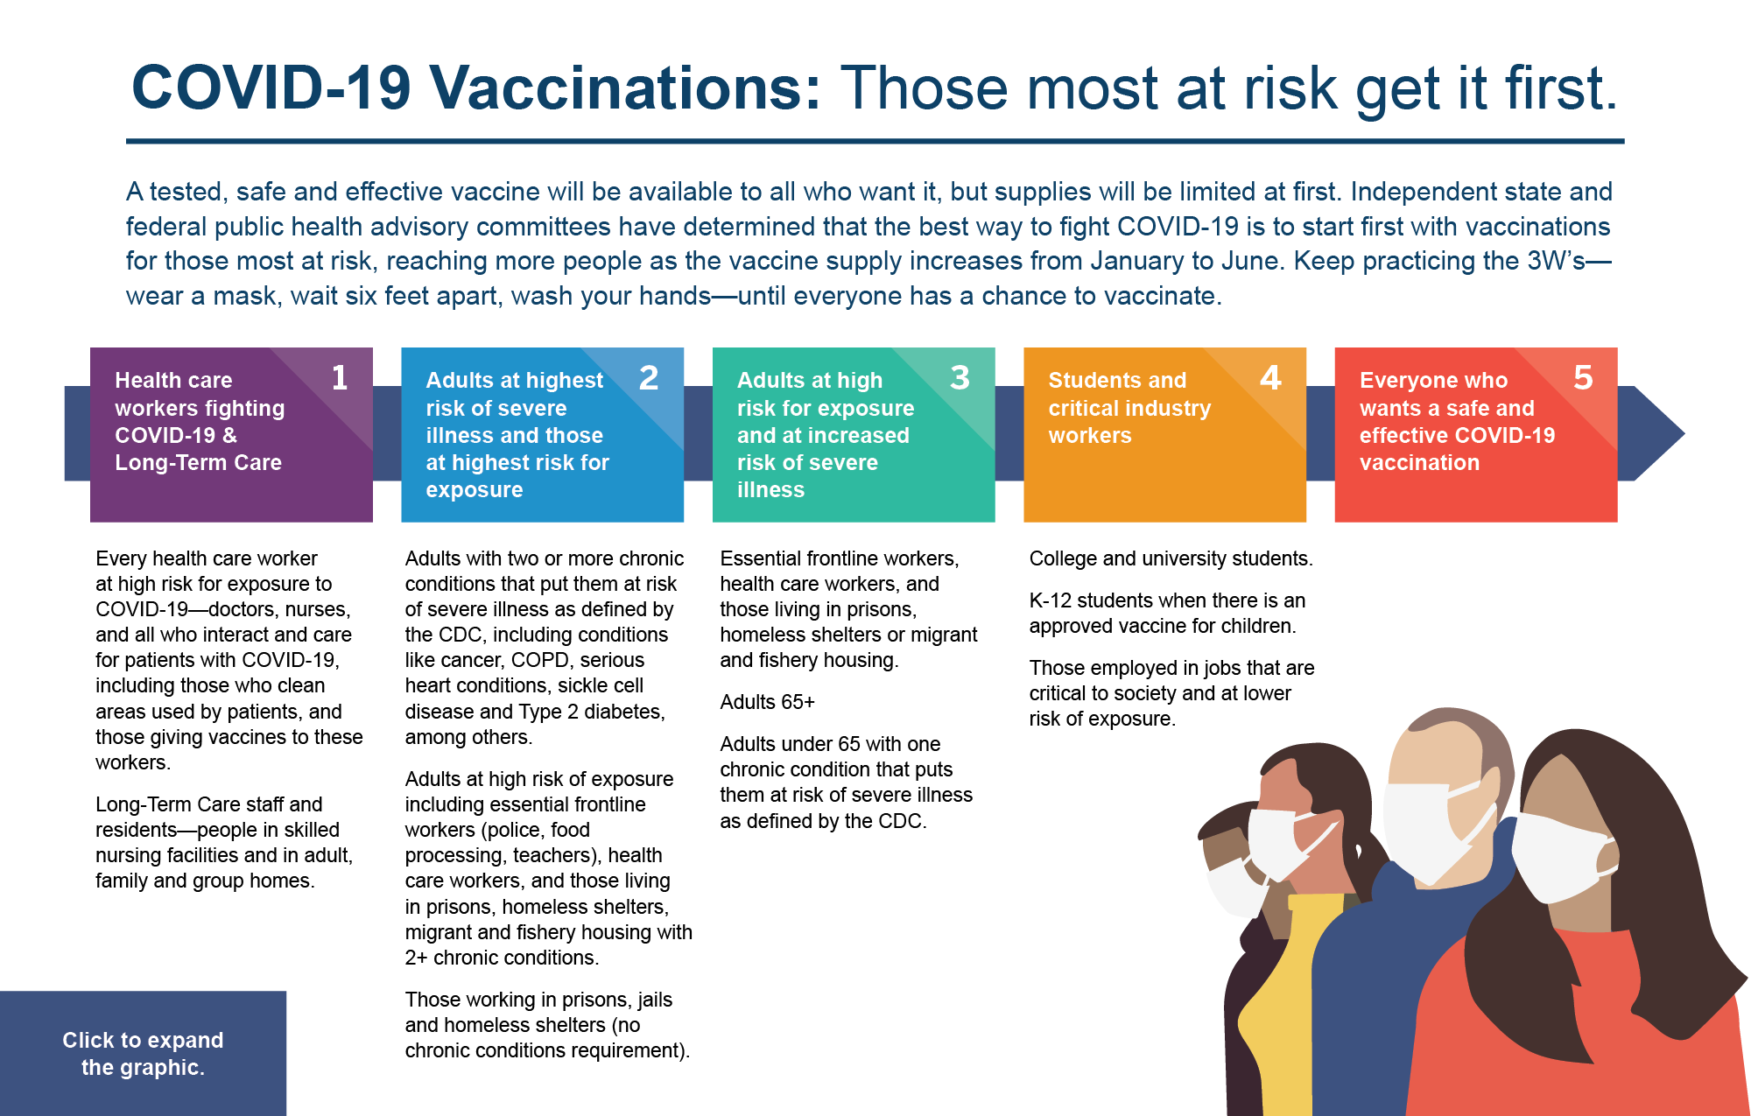

All Phase Priority Overview

Detailed Phase 1 Priority List

Detailed Phase 2 Priority List

Detailed Phase 3 and 4 Priority List

How Vaccines Work

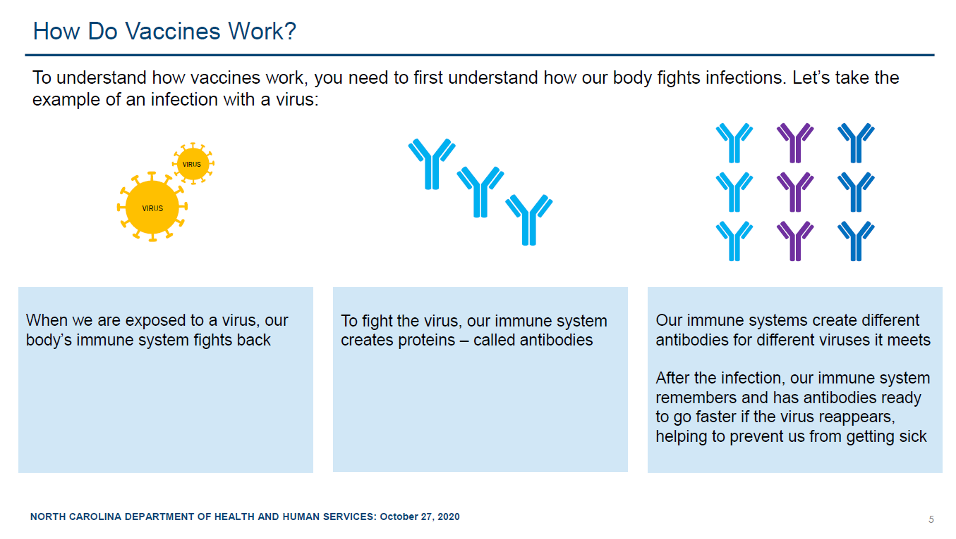

Vaccine Development, Manufacturing, and Distribution

Vaccine Operational Plan Overview

Vaccine Journey

High Level Talking Points

In-depth Talking Points (from CDC)
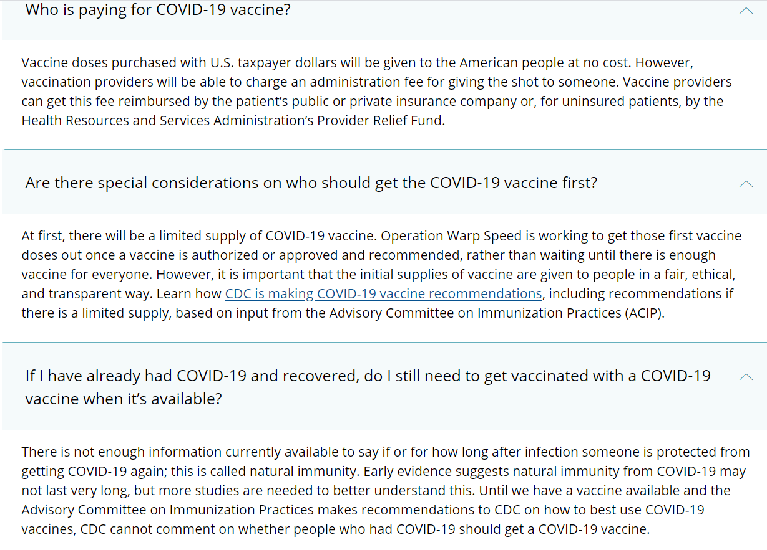

What is CVMS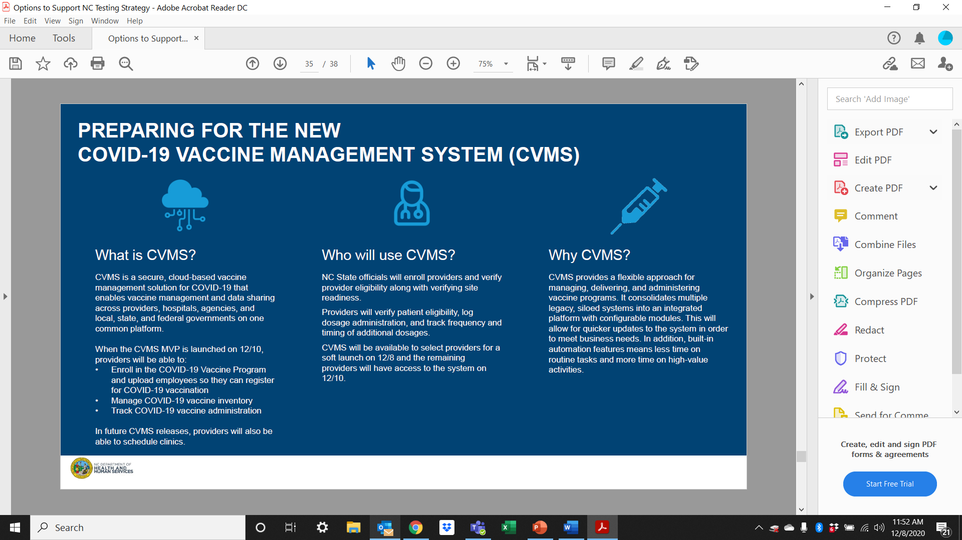

CVMS Training

This page intentionally left blank

Reported Side Effects from Moderna Vaccine

Reported Side Effects from Moderna Vaccine

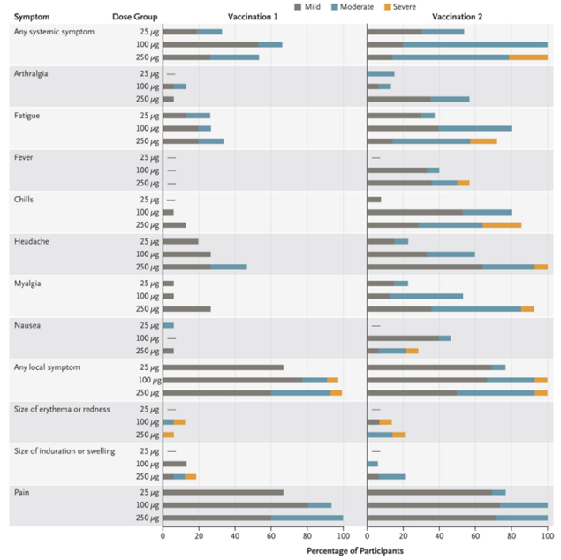
Retrieved from: New England Journal of Medicine https://www.nejm.org/doi/full/10.1056/nejmoa2022483

Pfizer Clinical Trial Overview
Pfizer Clinical Trial Overview

Retrieved from: https://www.pfizer.com/science/coronavirus/vaccine on 12/9/2020

Moderna Clinical Trial Overview
