**This checklist contains recommended action items to help organizations ensure their readiness to receive and administer the COVID-19 vaccine. Providers must be approved through the Provider Enrollment portal before beginning the readiness checklist. The State will contact providers for enrollment in accordance with the Vaccine Distribution Prioritization framework. Please visit the NCDHHS COVID-19 website for further information:** [**https://covid19.ncdhhs.gov/vaccines**](https://covid19.ncdhhs.gov/vaccines)**.**

The action items below are grouped by topic (Onboarding, Training, Communications and Vaccine Administration Preparation) and listed in recommended sequence to address. Action items that are shaded blue are only applicable to Health Care Provider (HCP) organizations that are enrolled with the State of North Carolina to administer COVID-19 vaccines.

Supporting reference materials can be found in the Appendix beginning on page 11.

Please contact the COVID-19 Vaccine Management System (CVMS) Help Desk at [CVMS-help@dhhs.nc.gov](mailto:CVMS-help@dhhs.nc.gov) with any questions related to this Readiness Checklist.

**Onboarding:**

|  | Action Item | Supporting Information |
| --- | --- | --- |
|  | 1. Identify internal single point of contact for your employees to send questions or provide feedback related to the administration of COVID-19 vaccine. | Identifying and providing employees a point of contact within your organization will give employees a clear channel to get answers to their questions or communicate issues related to the COVID-19 vaccination process.  Any questions related to NCID or CVMS access should be directed through the designated point of contact. |
|  | 1. **Enrolled HCP Organization Only:** Identify your organization’s users that need access to CVMS Healthcare Provider Portal and confirm that these users have a valid NCID. Instruct users that do not have an NCID to create an NCID and provide it to you. | See Appendix A for a summary of the two profiles in CVMS to help you determine which profile is appropriate for each your identified CVMS user’s needs.  Instructions for a user to create an NCID:   1. Navigate to <https://ncid.nc.gov/> 2. Click **Register!** (in the bottom right corner of the blue box) 3. Click **Business** user type option 4. Complete the required fields to create an NCID 5. Follow the steps to access your NCID account **and** create your security questions   See the NC Immunization Branch website for the HCP User Onboarding Template and instructions/user guide on how to complete the onboarding form: <https://immunize.nc.gov/providers/covid-19training.htm> |
|  | 1. Fill out the State-provided Recipient Bulk Upload Template with the requested information for each of your eligible employees or individuals that meet the Phase 1 criteria to receive the COVID-19 vaccine.   The Recipient Bulk Upload Template provides eligible employees or individuals with access to the CVMS Recipient Portal, where they must complete a health questionnaire before receiving the COVID-19 vaccine.   When vaccines are available and you have obtained access to CVMS, you will be able to upload your completed Recipient Bulk Upload Template into CVMS so that the identified employees or individuals can complete their registration process in CVMS. | See Appendix B for the North Carolina CDC COVID-19 Vaccination Program Phase 1 Prioritization / Eligibility Matrix.  See the NC Immunization Branch website for the Recipient Bulk Upload Template and user guide: <https://immunize.nc.gov/providers/covid-19training.htm>. This template should be completed for all users associated with the Provider Organization (and does not need to be location specific). See below for definitions of Risk column and Type column in the Recipient Bulk Upload Template.  **FIELD DEFINITIONS FOR RECIPIENT BULK UPLOAD TEMPLATE**​   * **RISK (column D):**Enter "High" if the employee is responsible for one or more of the following: caring/cleaning in areas with COVID-19 patients, performing tasks with high risks of aerosolization (Intubation, Bronchoscopy, Suctioning, Invasive Dental Procedures, Invasive Specimen Collection, CPR), responsible for handling decedents with COVID-19, or planning to administer the COVID Vaccine. Otherwise enter “Low” if the employee does not meet any of the above criteria. * **TYPE (column E):**Enter “Employee” if person is working for the organization or enter “Individual” if the person is a resident of the organization (e.g., residents of a nursing home)​. |

**Training:**

|  | Action Item | Supporting Information |
| --- | --- | --- |
|  | 1. **Enrolled HCP Organization Only:** Provide orientation and training materials to your organization’s designated primary and back-up vaccine coordinators. | The designated primary and back-up vaccine coordinators must review the CDC’s Vaccine Storage and Handling Toolkit, which includes the COVID-19 Vaccine Addendum and complete the COVID-19 Vaccine Training: General Overview of Immunization Best Practices for Healthcare Providers and the CDC’s You Call the Shots: Vaccine Storage and Handling module.  <https://www.cdc.gov/vaccines/hcp/admin/storage/toolkit/index.html>  <https://www2.cdc.gov/vaccines/ed/covid19/>  <https://www2a.cdc.gov/nip/isd/ycts/mod1/courses/sh/ce.asp>  Please see link below for CVMS Healthcare Provider Portal Log In and Getting Started User Guide:  [https://immunize.nc.gov/providers/ncip/training/CVMS%20Provider%20Portal%20Log %20In%20and%20Getting%20Started%20User%20Guide.pptx](https://immunize.nc.gov/providers/ncip/training/CVMS%20Provider%20Portal%20Log%20In%20and%20Getting%20Started%20User%20Guide.pptx) |
|  | 1. **Enrolled HCP Organization Only:** Train your staff that are designated to receive COVID-19 vaccines and manage inventory levels in CVMS on how to: 2. Receive COVID-19 vaccine shipments in CVMS 3. How to document and manage discrepancies between shipped quantities and actually received quantities 4. Look up and document (both on packaging and in CVMS) the Beyond Use for all COVID-19 vaccines 5. How to receive emails from the manufacturer on shipment status and temperature excursions 6. How to contact the manufacturer or CVMS Help Desk if there are any issues with the vaccine shipment 7. Make adjustments to inventory on-hand in CVMS due to spoilage, wastage, or returns 8. How to request or process transfers of COVID-19 vaccine inventory 9. How to return COVID-19 vaccine shipping containers to the manufacturer for reuse 10. How to return COVID-19 vaccines to the manufacturer if directed to do so. | Training materials for Receiving and Processing Vaccine Shipments can be found at the link below:  [https://immunize.nc.gov/providers/ncip/training/CVMS%20Provider%20 Portal%20Receiving%20and%20Processing%20Vaccine%20Shipments %20User%20Guide.pptx](https://immunize.nc.gov/providers/ncip/training/CVMS%20Provider%20Portal%20Receiving%20and%20Processing%20Vaccine%20Shipments%20User%20Guide.pptx)  Training materials for Inventory Wastage and Return can be found at the link below:  [https://immunize.nc.gov/providers/ncip/training/CVMS%20Provider%20Portal%20Inve ntory%20Wastage%20Return%20and%20Transfer%20User%20Guide.pptx](https://immunize.nc.gov/providers/ncip/training/CVMS%20Provider%20Portal%20Inventory%20Wastage%20Return%20and%20Transfer%20User%20Guide.pptx)  Links to the CDC website to look up Beyond Use Dates based on vaccine manufacturer lot numbers will be provided when available. |
|  | 1. **Enrolled HCP Organization Only:** Train your staff that are designated to handle and store COVID-19 vaccines on how to: 2. Properly handle the COVID-19 vaccines 3. Monitor and document the storage temperature for COVID-19 vaccines 4. Recharge COVID-19 vaccine shipping containers if they are being used to store COVID-19 vaccines (Pfizer) | Please see Appendix C at the end of this checklist for additional guidance on storage and recharging (Pfizer).  <https://www.cdc.gov/vaccines/hcp/admin/storage/toolkit/index.html>  Additional training materials will be provided when available. |
|  | 1. **Enrolled HCP Organization Only:** Train your staff that are designated to check-in employees prior to administration of COVID-19 vaccine on how to use CVMS to complete their responsibilities. | Training materials for HCP User check in are provided in the link below:    [https://immunize.nc.gov/providers/ncip/training/CVMS%20Provider% 20Portal%20Recipient%20Check-In%20User%20Guide.pptx](https://immunize.nc.gov/providers/ncip/training/CVMS%20Provider%20Portal%20Recipient%20Check-In%20User%20Guide.pptx) |
|  | 1. **Enrolled HCP Organization Only:** Train your staff that are designated to administer COVID-19 vaccines to eligible employees or individuals on how to: on how to: 2. Prepare the vaccine 3. Administer the vaccine 4. Provide the recipient a populated COVID-19 vaccination record card (mandatory requirement) 5. Document in CVMS | Training materials for vaccine administration can be found at the link below:  [https://immunize.nc.gov/providers/ncip/training/CVMS%20Provider%20Portal %20Vaccine%20Administration%20User%20Guide%20.pptx](https://immunize.nc.gov/providers/ncip/training/CVMS%20Provider%20Portal%20Vaccine%20Administration%20User%20Guide%20.pptx)  Training materials for Proof of Vaccine can be found in the link below:  [https://immunize.nc.gov/providers/ncip/training/CVMS%20Provider%20Portal %20Viewing%20Proof%20of%20Vaccination%20User%20Guide.pptx](https://immunize.nc.gov/providers/ncip/training/CVMS%20Provider%20Portal%20Viewing%20Proof%20of%20Vaccination%20User%20Guide.pptx)  Information on COVID-19 record card:   * COVID-19 vaccination record cards will be provided as part of vaccine ancillary kits. Vaccination providers should provide a completed card with accurate vaccine information (i.e., vaccine manufacturer, lot number, date of first dose administration, and second dose due date), and give them to each patient who receives vaccine to ensure a basic vaccination record is provided.   Vaccination providers should encourage vaccine recipients to take a picture of the vaccine card with their cell phone to remind them of the next due date for the second dose, and keep the card in case the CVMS or other system is not available when they return for their second dose. |
|  | 1. **Enrolled HCP Organization Only:** Train your designated vaccine administrators on how to report an adverse event in VAERS following a COVID-19 vaccine administration. | Per the CDC COVID-19 Vaccination Program Provider Agreement, COVID-19 vaccination providers are required to report adverse events following COVID-19 vaccination and should report clinically important adverse events even if they are not sure if the vaccination caused the event.  <https://www.cdc.gov/vaccinesafety/ensuringsafety/monitoring/vaers/index.html> |

**Communications:**

|  | Action Item | Supporting Information |
| --- | --- | --- |
|  | 1. Consider developing internal FAQs for your organization to help employees understand the COVID-19 vaccination process. | This document could include details on the specific process for employees to schedule and receive the COVID-19 vaccine, determining if eligible employees/individuals should pre-register in CVMS or register upon arriving to receive the vaccine, timing on when the COVID-19 vaccine is expected to be received, where to go to learn more about the COVID-19 vaccines, and your organization’s policy or expectations on employees getting the COVID-19 vaccine. |
|  | 1. Develop and distribute communications to identified employees or individuals that were uploaded into CVMS on the process, timing, and logistics to receive the COVID-19 vaccine (two doses). | Communications could provide the identified employees or individuals the following key points:   1. They were identified by the organization as being eligible for inclusion in the first Priority Tier to receive the COVID-19 vaccine. 2. Their name and email address were uploaded into the State of North Carolina’s COVID-19 Vaccine Management System (CVMS). 3. They will receive an email from CVMS with instructions on how to complete their registration to receive the COVID-19 vaccine. 4. They will receive additional details on when and where they should go to receive the two doses of the COVID-19 vaccine once the vaccines are received by the organization. 5. Where they can view any developed FAQs or other resources related to the COVID-19 vaccination program.   Who they can contact within the organization with any questions related to the COVID-19 vaccination program. |

**Vaccine Administration Preparation:**

|  | Action Item | Supporting Information |
| --- | --- | --- |
|  | 1. Determine process for prioritizing and scheduling employees or individuals to receive the COVID-19 vaccine (two doses) and logistics on where employees or individuals will need to go to receive the COVID-19 vaccine. | The Pfizer and Moderna COVID-19 vaccines require two doses. The minimum number of days between the first and second dose is expected to be 21 calendar days for the Pfizer vaccine and 28 calendar days for the Moderna vaccine. |
|  | 1. **Enrolled HCP Organization Only:** Understand how to view status of COVID-19 vaccine shipments to your organization in CVMS. | Training materials for shipment handling can be found at the link below:  [https://immunize.nc.gov/providers/ncip/training/CVMS%20Provider%20Portal% 20Receiving%20and%20Processing%20Vaccine%20Shipments%20User%20 Guide.pptx](https://immunize.nc.gov/providers/ncip/training/CVMS%20Provider%20Portal%20Receiving%20and%20Processing%20Vaccine%20Shipments%20User%20Guide.pptx) |
|  | 1. **Enrolled HCP Organization Only:** If storing the Pfizer vaccine in an ultra-cold freezer, ensure proper equipment and processes are being used (non-exhaustive list):    1. Freezer must hold vaccine at a temperature of -80°C to -60°C (-112°F to -76°F)    2. Use a Digital Data Logger (DDL) for temperature monitoring    3. For accurate ultra-cold temperature monitoring, it is essential to use an air-probe as opposed to pure propylene glycol    4. Ensure the DDL has an alarm for out of range temperatures, low battery alarm, and displays current/min/max temperatures    5. Ensure DDL has current and valid certificate of calibration | Please see Appendix C for information on storing the Pfizer vaccine.  <https://www.cdc.gov/vaccines/hcp/admin/storage/toolkit/index.html> |
|  | 1. **Enrolled HCP Organization Only:** If storing the Pfizer vaccine in an ultra-cold freezer, ensure capacity. Each tray contains 195 vials and is roughly 9”x9”x1.6” inches. |  |
|  | 1. **Enrolled HCP Organizations Only:** If storing the Pfizer vaccine in dry-ice, ensure proper equipment and processes are being used (non-exhaustive list):    1. Locate a dry-ice vendor    2. Create an account with the identified Dry-Ice vendor    3. Discuss and coordinate antic pated needs with the dry-ice vendor | Please see Appendix C for information on storing the Pfizer vaccine.  <https://www.cdc.gov/vaccines/hcp/admin/storage/toolkit/index.html> |
|  | 1. **Enrolled HCP Organization Only:** Obtain copy of Emergency Use Authorization Fact Sheet for each COVID-19 vaccine product your organization receives and establish process to provide a printed copy of this document to each recipient prior to administration of the vaccine (both first and second dose). | Link to the Emergency Use Authorization Fact Sheet can be sound in the link below:  [https://www.fda.gov/emergency-preparedness-and-response/coronavirus-disease-2019-covid-19/pfizer-biontech-covid-19-vaccine](https://urldefense.com/v3/__https:/t.emailupdates.cdc.gov/r/?id=h3782c52d*2C12cafe53*2C12cbecb9&ACSTrackingID=USCDC_11_30-DM44580&ACSTrackingLabel=Vaccine*20Code*20Set*20Release*20Notes*2012*2F14*2F2020&s=ATCxeIR2wEaziP14H4uNn7SkZkmFJ_jVTu7xSomK-OM__;JSUlJSUlJSUl!!HYmSToo!JU_nuW_CaDO3jlcLyI4B9hzRo5ORxgNyAWkLTeYHK_elaIpTNh9i-FLJpACZL5zhmrlwEA$) |
|  | 1. **Enrolled HCP Organization Only:** Establish process to provide a printed copy of the v-safe Information Sheet to each recipient after administration of the COVID-19 vaccine (both first and second dose) to support adverse effect monitoring. | Please see the Appendix D for the v-safe Information Sheet. |

**Appendix A. CVMS Profiles**



**Appendix B. Vaccine Distribution Prioritization Framework**

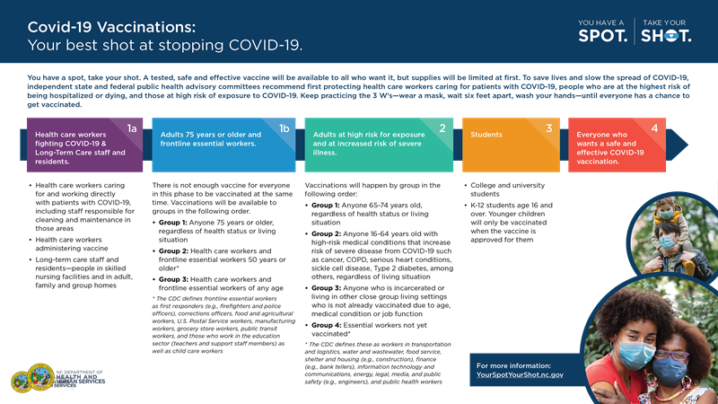

**Appendix C. Pfizer Vaccine Storage Guidance per the CDC (as of 11/17)**

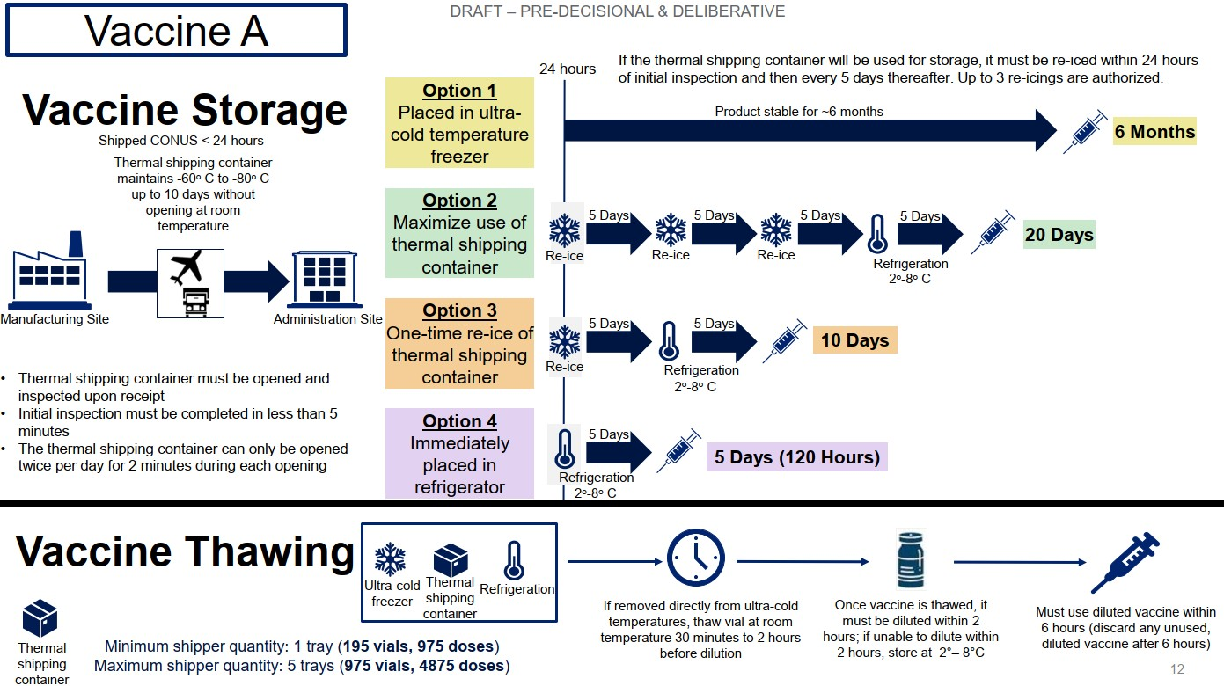

**Appendix D. v-safe Information Sheet**

