Evaluation Instructions for Attendees
Thank you for attending the 2021 Annual State-Based Uniform Data System (UDS) Training.
We are very interested in your feedback on this year's UDS training series conducted as webinars and would like to ask you to complete the evaluation survey within 48 hours of the final session.
Instructions are provided below to aid you with the process. The evaluation link is below and will be provided to participants by the Primary Care Association (PCA) on the day of the final session through the webinar platform and by email following the final session.
We ask that each attendee only submit one evaluation pertaining to your overall experience with this training series.

How to Complete the Evaluation
1. Navigate to the evaluation survey link: https://redcap.link/UDSEvaluation2021
2. Please select the date you are completing the evaluation.
3. Please select the PCA whose 2021 Annual State-Based Training you attended using the drop-down list.
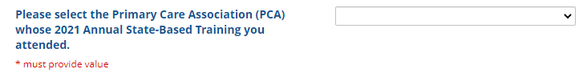
4. Complete the evaluation.
5. Please remember to click on 'SUBMIT' when you are finished. Thank you!

