Sexual Orientation and
Gender Identity (SOGI)
Playbook

Project Team:
Marwan Haddad, Kasey Harding-Wheeler, Erica Preston, Grace Capreol, Doug Janssen, Idiana Velez, Omar Perez, Maria Lorenzo, Pat Mik, Stephanie Moses, Madeline Ehrlich

Goal:
Implement a process for efficient and effective collection and use of sexual orientation and gender identity data across all patients 13 years of age and older at CHCI.

Playbook Table of Contents

#1. SOGI Questionnaire

#1a. Administering the SOGI Questionnaire in a Medical Provider Visit

#1b. Administering the SOGI Questionnaire in a Nursing Visit

#1c. Administering the SOGI Questionnaire in a Behavioral Health Visit

#2. Documenting patient responses in eCW

#2a. Documentation for Transgender Patients

#3. Patients with complete SOGI Profiles

#4. Reporting SOGI Data
Overall Workflow 1: Medical Provider Visit
Medical Assistant (MA) checks planned care dashboard during huddle

MA flags need for SOGI collection and prepares Questionnaire

Patient Presents for Medical Provider Visit

Medical Assistant presents Questionnaire to patient

MA explains Questionnaire and states provider will discuss any questions

Patient completes Questionnaire and hands to provider

No
Documentation complete
Yes
Check the Transgender box in Info & Document Preferred Name and Pronoun in Nickname field
Transgender Patient or Gender Identity different than Sex Assigned at Birth?
Provider or MA enters the responses into Social History in eCW
Provider reviews responses and asks patient if they have any questions
Overall Workflow 2: Nursing Visit
Nurse checks planned care dashboard or Social History and flags need for SOGI collection

Patient Presents for Nursing Visit

Nurse informs patient of reason for SOGI collection and answers any questions

Nurse presents Questionnaire to patient or verbally asks the questions

Patient completes Questionnaire and hands back to Nurse or answers the questions

Nurse reviews responses and asks patient if they have any questions
Nurse enters the responses into Social History in eCW
Yes
No
Transgender Patient or Gender Identity different than Sex Assigned at Birth?
Documentation complete
Check the Transgender box in Info & Document Preferred Name and Pronoun in Nickname field
Overall Workflow 3: BH Clinician Individual Visit
BH clinician reviews dashboard or Social History and flags need for SOGI collection

Patient Presents for BH Visit

BH clinician informs patient of reason for SOGI collection and answers any questions

BH clinician presents Questionnaire to patient or verbally asks the questions

Patient completes Questionnaire and hands back to clinician or answers the questions

Clinician reviews responses and asks patient if they have any questions
Clinician enters the responses into Social History in eCW
No
Yes
Transgender Patient or Gender Identity different than Sex Assigned at Birth?
Documentation complete
Check the Transgender box in Info & Document Preferred Name and Pronoun in Nickname field
Play #1: The SOGI Questionnaire

Name/MR#____________
Date ____________
Screening Questionnaire Form

- Do you think of yourself as:
  - Straight or heterosexual
  - Lesbian, gay, or homosexual
  - Bisexual
  - Questioning
  - Other:______________________
  - Don’t know
  - Choose not to disclose
- Do you think of yourself as:
- Male
- Female
- Transgender Male/Trans Man/Female to Male (FTM)
- Transgender Female/Trans Woman/ Male to Female (MTF)
- Genderqueer (neither exclusively male nor female)
- Additional gender category/Other, please specify:_____________________
- Questioning
- Don’t know
- Choose not to disclose
- What sex were you assigned at birth on your original birth certificate?
- Male
- Female
- Choose not to disclose
- Preferred pronoun. Specify:
- He/Him
- She/Her
- They/Them
- Other:____________________________

- Preferred Name:__________________________
Nombre/MR#:_________________
Fecha: _______________

Cuestionario Medico
Gracias por completar este formulario. Sus respuestas nos ayudaran a proveerle un cuidado completo y con respeto.
- Como usted se considera:
- Heterosexual (Straight)
- Homosexual, Lesbiana (Gay)
- Bisexual
- Otro: ______________________
- Cuestionando
- No Se
- Prefiero no contester

- Como usted se considera:
- Hombre
- Hembra
- Transgenero Masculino/Hombre-Trans/ Hembra a Hombre
- Transgenero Feminino/Mujer-Trans/ Hombre a Hembra
- No comformista a base de genero/Ni exclusivamente hombre o hembra
- Categoria adicional de genero / Otro, por favor especifique:______________________
- Cuestionando
- No se
- Prefiero no contestar
3. Qué sexo le asignaron al nacer en su acta de nacimiento original?
- Hombre
- Hembra
- Negarse a responder

- Pronombre preferido, por favor especifique:
- El
- Ella
- Ellos/Ellas/Los/Las
- Otro:__________________
5. Nombre preferido: _____________________

Play #1a. Medical Provider Visit

Overview:
The purpose of this step is to collect sexual orientation and gender identity (SOGI) information at least once on all patients 13 years of age and older coming in for a medical visit with a provider.

Key Steps:
- The medical assistant (MA) will check the planned care dashboard during their huddle.
- If the patient requires any component of the SOGI collection, the MA will take note and prepare the SOGI questionnaire to give to the patient.
- When the patient presents for the visit, the MA rooms the patient and hands the SOGI questionnaire to the patient. The MA will inform the patient that CHC is collecting this information on all patients as a standard of care and that the provider will review the questionnaire with them. Any questions they may have about the questionnaire can be discussed with the provider if needed.
- The patient fills out the questionnaire.
- The provider reviews the questionnaire with the patient during the course of the visit and answers any questions the patient may have.
- The medical provider can enter the SOGI information in eCW under Social History or can hand the questionnaire to the MA to enter the information.
- If the patient’s gender identity is different than the gender assigned at birth or if transgender male, transgender female, genderqueer, or other categories are checked, in addition to entering this information in Social History, the TGNC box in Patient Information must be checked. The gender field in Patient Information must remain the same gender as is listed on the insurance.
- If the pronouns indicated do not correspond with the sex assigned at birth and/or the preferred name is different from the name listed on the insurance, the name and pronouns to use should be entered in the Nickname field in Patient Information under Miscellaneous Info in the following format “John (He/Him)” or “Jane (She/Her)”.
Play #1b. Nursing Visit

Overview:
The purpose of this step is to collect sexual orientation and gender identity (SOGI) information at least once on all patients 13 years of age and older coming in for a medical visit with a Nurse.

Key Steps:
- The nurse will check the planned care dashboard or Social History to see if the patient requires any component of the SOGI collection either before or during the visit.
- When the patient presents for the visit, the nurse either hands the SOGI questionnaire to the patient or obtains the SOGI information verbally. The nurse will inform the patient that CHC is collecting this information on all patients as a standard of care.
- The patient fills out the questionnaire or answers the questions verbally.
- The nurse reviews the questionnaire with the patient during the course of the visit and answers any questions the patient may have.
- The nurse enters the SOGI information in eCW under Social History. If the patient’s gender identity is different than the gender assigned at birth or if transgender male, transgender female, genderqueer, or other categories are checked, in addition to entering this information in Social History, the TGNC box in Patient Information must be checked. The gender field in Patient Information must remain the same gender as is listed on the insurance.
- If the pronouns indicated do not correspond with the sex assigned at birth and/or the preferred name is different from the name listed on the insurance, the name and pronouns to use should be entered in the Nickname field in Patient Information under Miscellaneous Info in the following format “John (He/Him)” or “Jane (She/Her)”.
Play #1c. BH Provider Individual Visit

Overview:
The purpose of this step is to collect sexual orientation and gender identity (SOGI) information on all patients 13 years of age and older at least once coming in for a behavioral health (BH) individual visit (this does not include WHOs or group visits).

Key Steps:
- Before each individual visit, the BH provider will check the BH dashboard to see if SOGI information needs to be collected.
- If the patient requires any component of the SOGI collection, the BH provider either hands the SOGI questionnaire to the patient or obtains the SOGI information verbally. The BH provider will inform the patient that CHC is collecting this information on all patients as a standard of care.
- The patient fills out the questionnaire or answers the questions verbally.
- The BH provider reviews the questionnaire with the patient during the course of the visit and answers any questions the patient may have.
- The BH provider enters the SOGI information in eCW under Social History.
- If the patient’s gender identity is different than the gender assigned at birth or if transgender male, transgender female, genderqueer, or other categories are checked, in addition to entering this information in Social History, the TGNC box in Patient Information must be checked. The gender field in Patient Information must remain the same gender as is listed on the insurance.
- If the pronouns indicated do not correspond with the sex assigned at birth and/or the preferred name is different from the name listed on the insurance, the name and pronouns to use should be entered in the Nickname field in Patient Information under Miscellaneous Info in the following format “John (He/Him)” or “Jane (She/Her)”.

Play #2: Documenting SOGI in eCW

Overview: The purpose of this step is to electronically document patient responses to the SOGI Questionnaire. Electronic documentation in the Social History section of eClinicalWorks will provide timely and efficient access to information for clinical staff across all disciplines and roles.

Key Steps
- In the Progress Note, navigate to the Social History Section
- Click in the Details section next to Sexual Orientation
  - From the structured drop-down, choose the patient response
  - In the Date Collected field, click the Notes section to populate a calendar date
- Click Next at the bottom of that screen to move on to Gender Identity
- Complete these steps until you reach the Preferred Name field

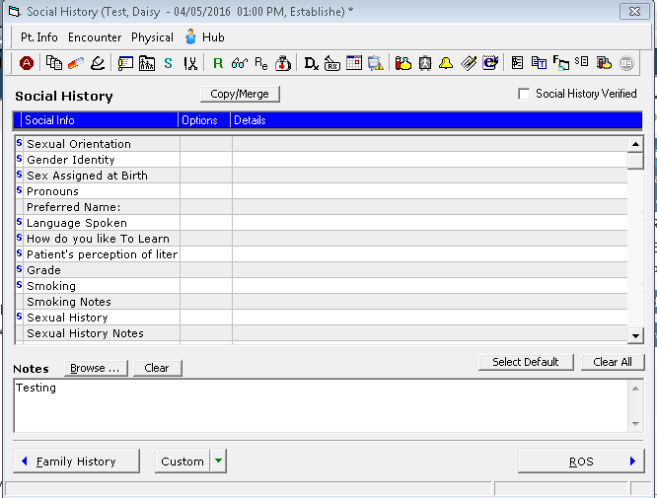
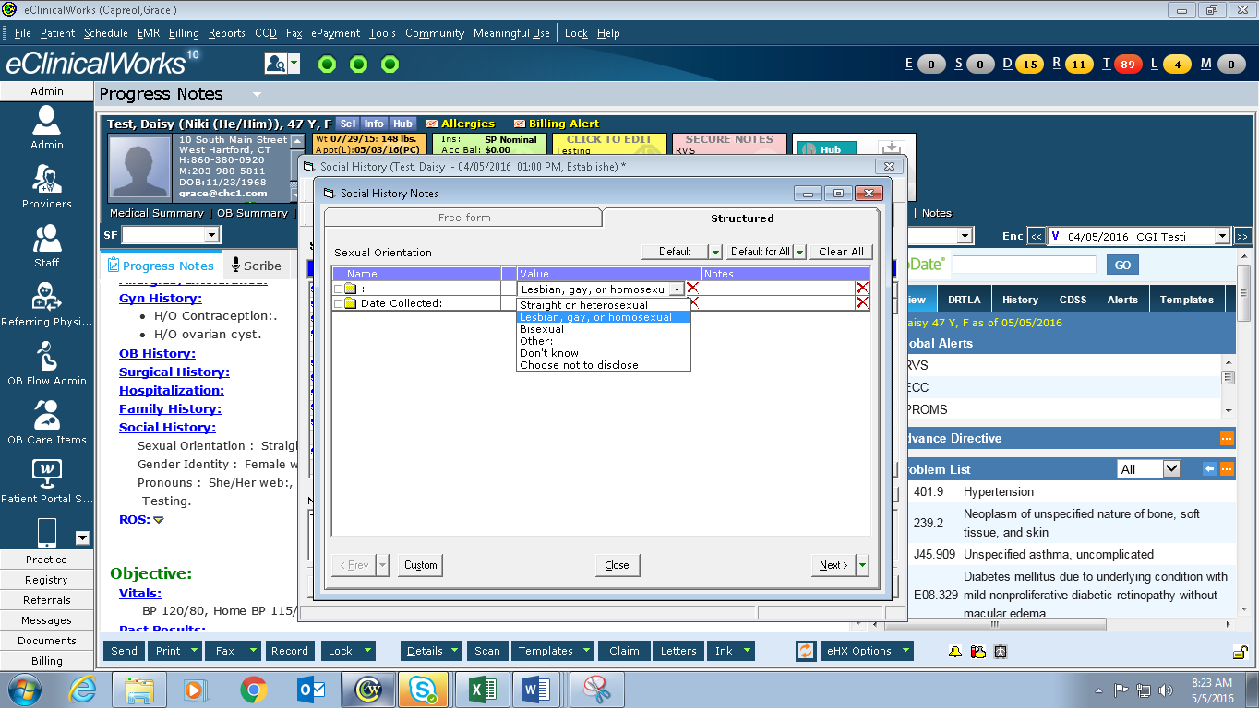

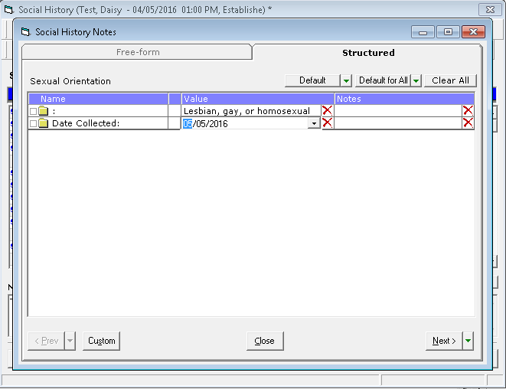

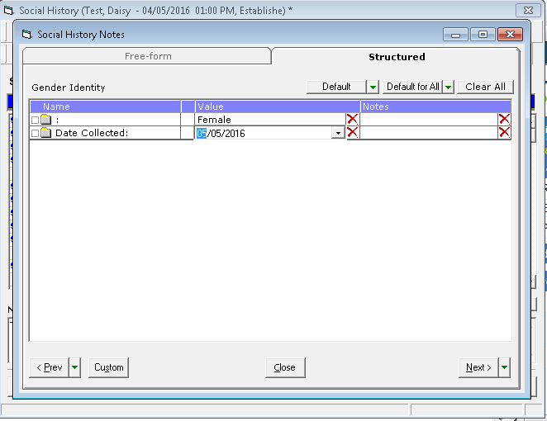
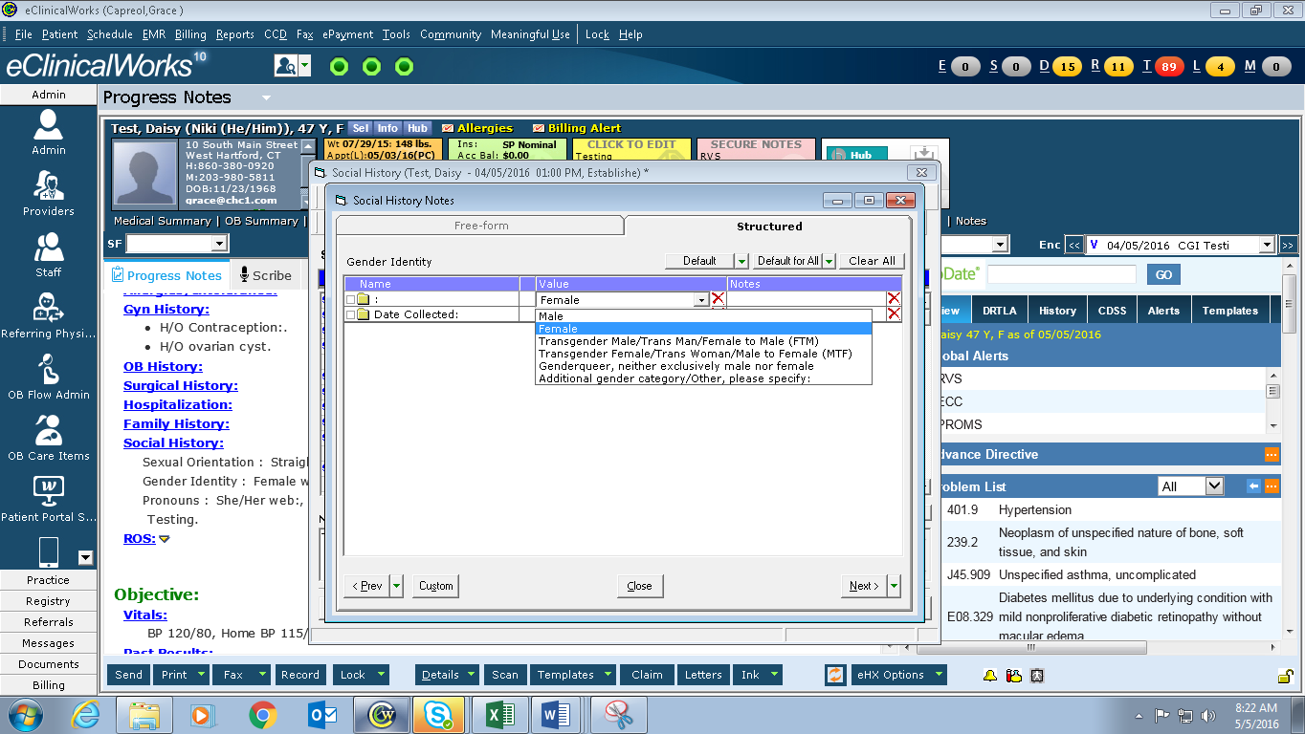
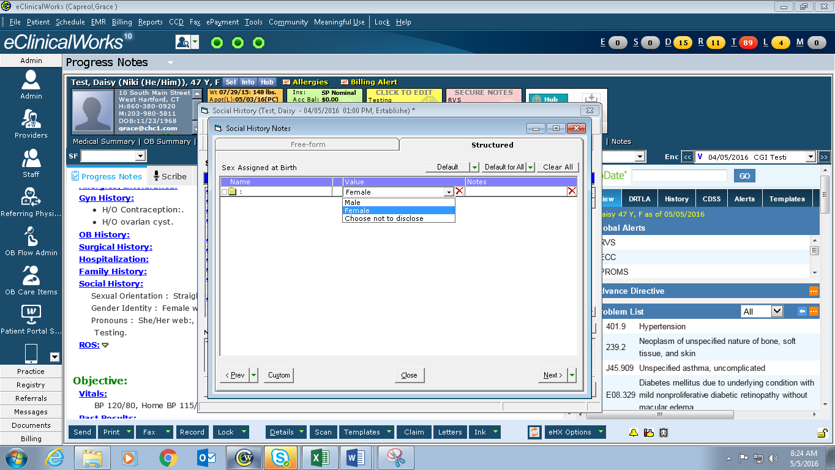

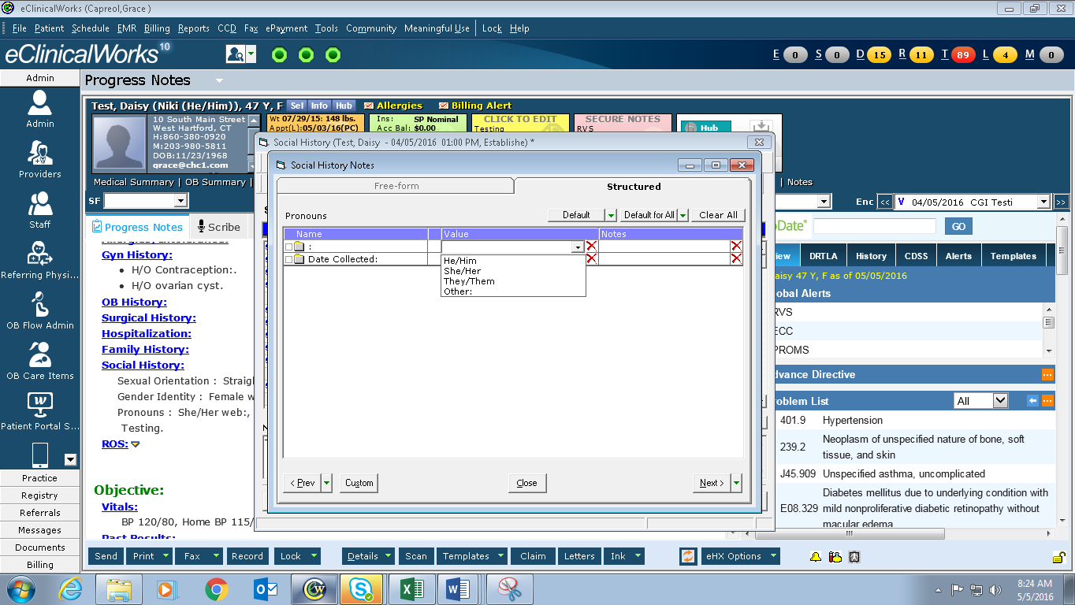

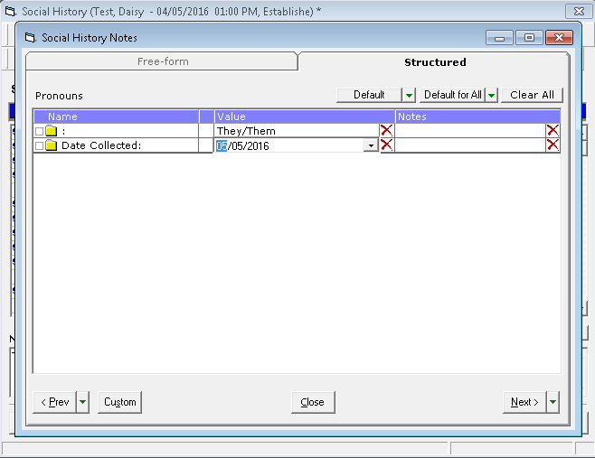

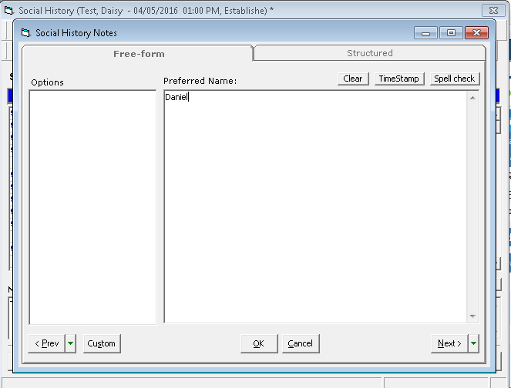

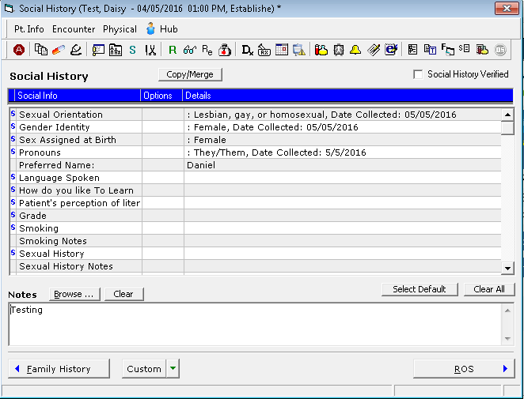

In the Progress Note:

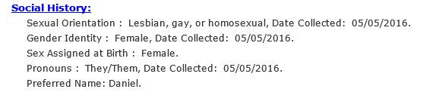

Right Chart Panel:
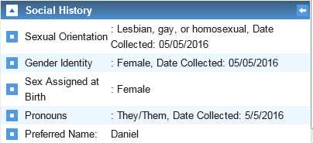
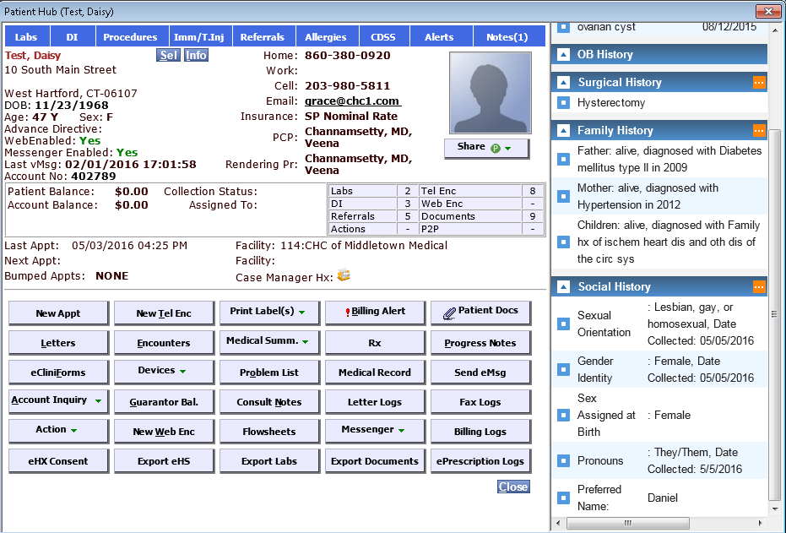

Right Chart Panel from the Hub:

Right Chart Panel from a TE:
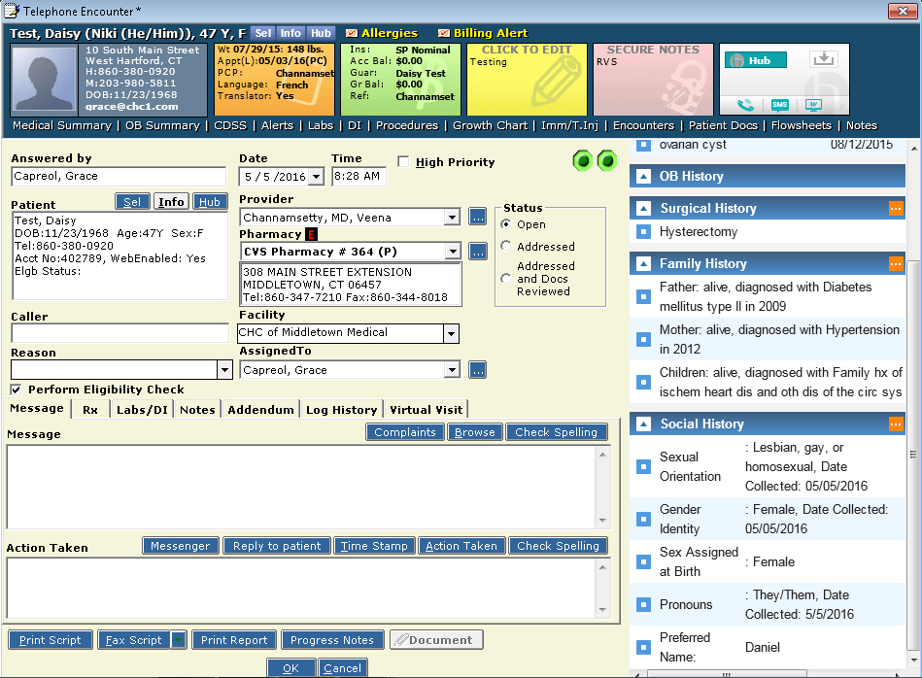

Play #2a. Documentation for Transgender Patients

Overview: The purpose of this play is to increase the visibility of important information regarding Transgender patients. In order to make preferred names and pronouns more visible, we document this information in the Info section of eCW as well as the social hx.

Key Steps:
- Document Gender Identity in Social History.
- If the patient’s gender identity is different than the gender assigned at birth or if transgender male, transgender female, genderqueer, or other categories are checked, also navigate to Patient Info.
- Click the TGNC box in the Info section.
- The gender field in Patient Info must remain the same gender as is listed on the insurance.
- If the pronouns indicated do not correspond with the sex assigned at birth and/or the preferred name is different from the name listed on the insurance, also click on Miscellaneous Info.
- Navigate to the Nickname field and enter Preferred name and pronouns in the following format: Name (Pronoun/s)
  - Ex: John (He/Him)

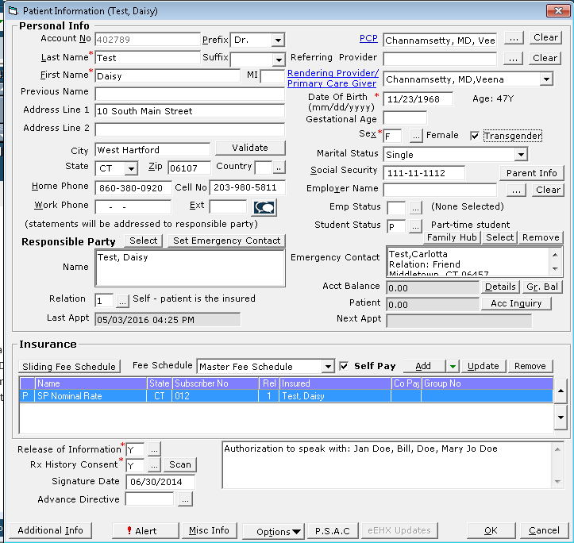

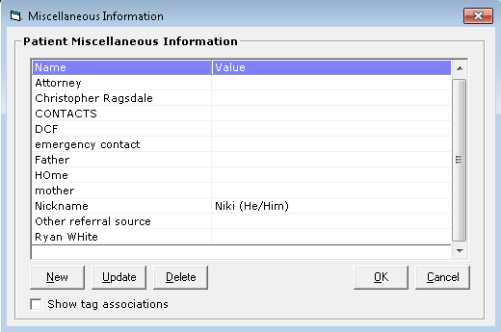

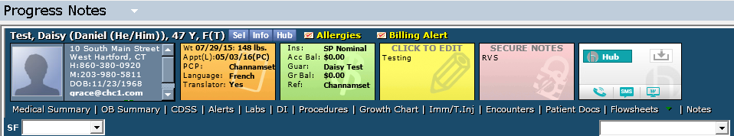

Play #3: Patients with Complete SOGI Profiles

Overview: The purpose of this play is to identify patients who have already received the SOGI Questionnaire and completed responses. We should identify these patients so that the information is refreshed as needed.

Key Steps:
- Check Social History section of the patient when rooming them.
  - The right-chart panel holds all the information an MA, Nurse, or BH Provider should require.
- Check Planned Care Dashboard.
  - Each missing SOGI Element w/ date collected (Sexual Orientation, Gender Identity, Sex Assigned at Birth) will be highlighted in Red.
  - If the patient’s gender identity is different than the gender assigned at birth or if transgender male, transgender female, genderqueer, or other categories are checked, preferred name and pronoun will highlight in Red if not collected.
- Check BH Dashboard.
  - Each missing SOGI Element w/ date collected (Sexual Orientation, Gender Identity, Sex Assigned at Birth) will be highlighted in Red.
  - If the patient’s gender identity is different than the gender assigned at birth or if transgender male, transgender female, genderqueer, or other categories are checked, preferred name and pronoun will highlight in Red if not collected.

Play #4: Reporting SOGI Data

Overview:

Key Steps:

Cube Report available from the CHC Analytics server
- Sexual Orientation
- Gender Identity
- Pronouns
- Sex Assigned at Birth

